First and foremost you need something to handle http requests.

Common gateway interface (CGI)

It is an environment that allows web servers to interact with executable programs that generate dynamic web pages.

“You'll find that PHP has shielded you from a lot of the knowledge needed to write a "normal" web application using a CGI. That's OK if you already know that stuff, but it's bad if you have never done lower-level code, or are trying to use different languages, because knowing the CGI layer provides a lot of knowledge that is needed to understand the whole HTTPD stack. Once you know the CGI layer, things like Sinatra, Rails, Django, Mojolicious and all the other frameworks out there suddenly make more sense, and you'll know when to take advantage of them or roll your own. And, PHP's place in the HTTP server will be clearer too, allowing you to pick and choose your tools better for the job at hand.”

(extract from wikipedia): Each Web server runs HTTP server software, which responds to requests from Web browsers. Generally, the HTTP server has a directory (folder), which is designated as a document collection — files that can be sent to Web browsers connected to this server.[6] For example, if the Web server has the domain name example.com, and its document collection is stored at /usr/local/apache/htdocs in the local file system, then the Web server will respond to a request for http://example.com/index.html by sending out the (pre-written) file at /usr/local/apache/htdocs/index.html.
CGI extends this system by allowing the owner of the Web server to designate a directory within the document collection as containing executable scripts (or binary files) instead of pre-written pages; this is known as a CGI directory. For example, /usr/local/apache/htdocs/cgi-bin could be designated as a CGI directory on the Web server. If a Web browser requests a URL that points to a file within the CGI directory (e.g., http://example.com/cgi-bin/printenv.pl), then, instead of simply sending that file (/usr/local/apache/htdocs/cgi-bin/printenv.pl) to the Web browser, the HTTP server runs the specified script and passes the output of the script to the Web browser. That is, anything that the script sends to standard output is passed to the Web client instead of being shown on-screen in a terminal window.
The CGI system also allows the Web browser to send information to the script via the URL or an HTTP POST request. If a slash and additional directory name(s) are appended to the URL immediately after the name of the script, then that path is stored in the PATH_INFO environment variable before the script is called. If parameters are passed to the script via an HTTP POST or GET request (e.g., a question mark appended to the URL, followed by param=value pairs), then those parameters are stored in the QUERY_STRING environment variable before the script is called. The script can then read these environment variables and adapt to the Web browser's request.
Setting up a CGI using Rack

First just create a file called config.ru in the root dir and paste that code:

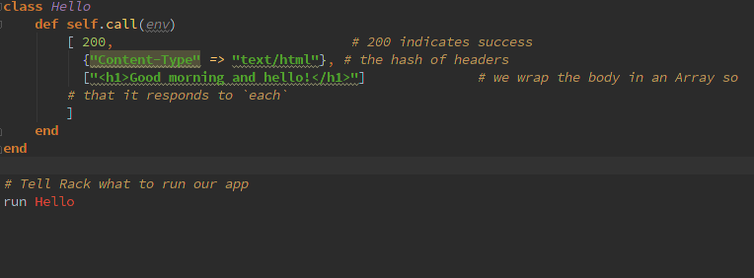
Then write rackup in the terminal. Congratulations, your
application is now available at http://localhost:9292

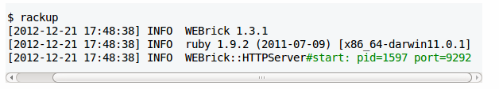
Building a middleware

By redefining the call method we can determine how we want the script to be executed. Here we ask it to display any text in the body in uppercase

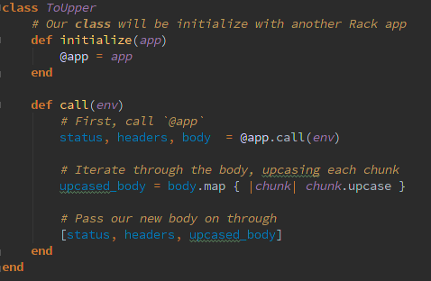

the methods Rack::request (called in the body of the call() method and Rack::response are complementary
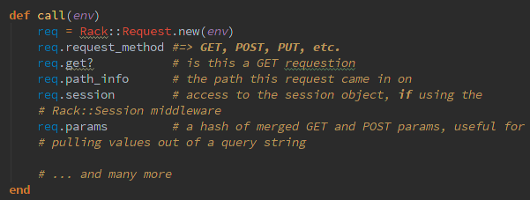

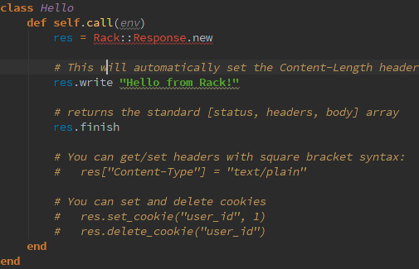
Outgoing data must be triplets. The env gives you access to incoming headers, host info, query string and other common information. The env is passed to the application which decides what to do. But what is env exactly?

def self.call(env)
[
200,
{},
[env.inspect]
]
end
Try this. You see that env is a raw data object, with all the info about the app and the environement.

Parsing a GET with a middleware

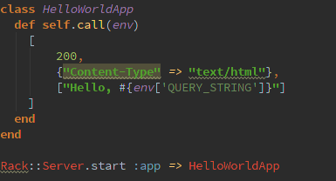

http://localhost:8080/?Piotr
returns Hello, Piotr

Rack::Request is simply a proxy for the env hash. The underlying env hash is modified so keep that in mind.

Rack::Request is an abstraction around the env hash. It provides access to thinks like cookies, POST paramters, and other common things. It removes boiler plate code. Here's an example.

In computer programming, boilerplate code or boilerplate is the sections of code that have to be included in many places with little or no alteration.
One form of boilerplate consists of declarations which, while not part of the program logic or the language's essential syntax, are added to the start of a source file as a matter of custom. The following Perl example demonstrates boilerplate:
#!/usr/bin/perl
use warnings;
use strict;

